Y1Q4W12

The axe and the angel guards

Ask: Have you ever borrowed something from someone and something bad happened to it? What happened? How did you feel? What did your friend do?

Say: When we borrow something, we should return it, looking the same as when we borrowed it, but sometimes something does go wrong.

Tell a personal story: or have someone tell a story about borrowing something and something going wrong; how each person felt and what had to happen to make it right.

Bible Story

Ask: If the maid had not done her work well, do you think that her masters would have listened to her?
Ask: What is a witness?

Sing Songs

Return to tables
Memory Verse: Fill in the blanks and then say the memory verse on the colouring page.
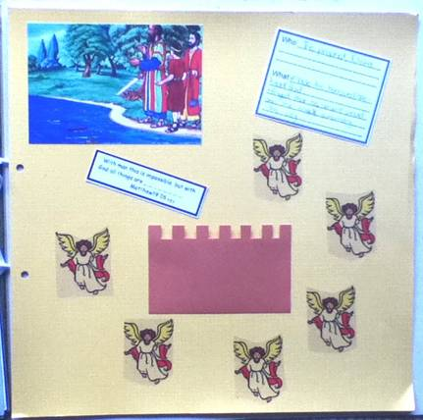
Scrapbooks
- Choose a cardboard
- Stick on Photo, Bible verse, Who/What Card and stickers.
- Cut slits in the top of the town wall (brown rectangle) and fold back alternating pieces.
- Stick angels around the town.

Discuss the following depending on age, interest and time:
Should we try and look after things that we borrow?
When and how should we borrow something that we borrow? (As soon as possible, in good condition)
Should we bother God about little things? (God cares about sparrows and flowers and counts our hairs)
Have you heard stories about angels helping people?

Ask: Does God still help people like Elisha helped the man with the borrowed axe?
Ask: Does God still send angels to protect people?
Read: A story about angels protecting people.

Finish with prayer

